Name_________________________Date_________________

Unit 1- Forces and Motion
Lesson 1- Motion
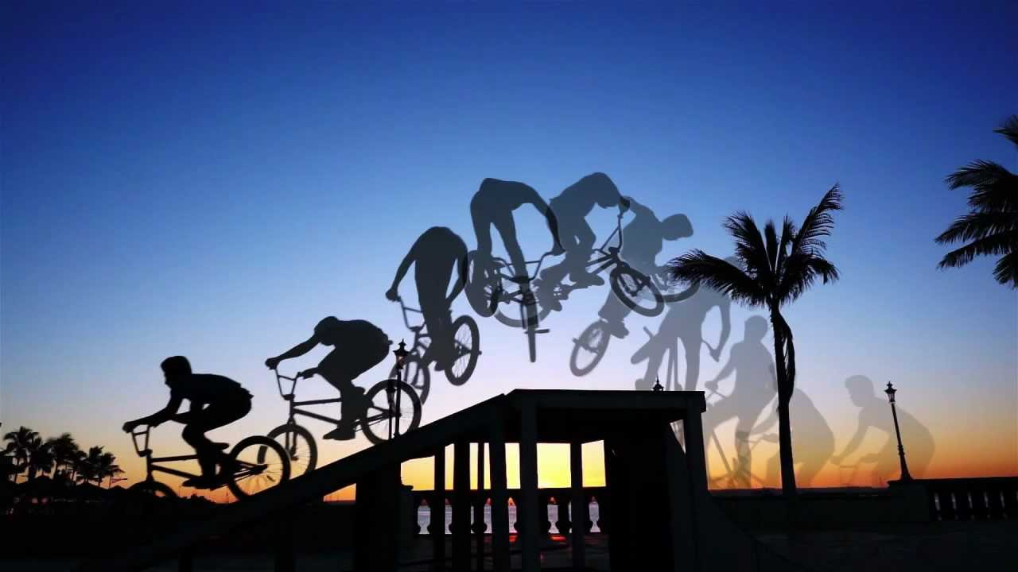

What does it mean to be in motion?

- An object is in motion if it __________________ position in relation to a certain place called a
________________________.

- Reference points are _________________ or objects used to
determine the _________________ of an object.

Relative Motion

Motion is _______________ as it depends on the reference point.
Measuring Motion

___________ is the many ways we measure motion. Speed is a
_________________ of the distance traveled per unit of
__________.
Finding Speed

Speed = Distance / Time s=d/t
Time = Distance / Speed t=d/s
Distance = Speed x Time d=st

A snail travels a distance of 10 m in 6,000 seconds. What is the snail’s average speed?

A blimp travels at 3 m/s for 1,500 s. What distance does the blimp cover in that time?

Lance Armstrong can ride his bicycle at speeds of 15 m/s. If he is traveling at this speed, how long will it take him to travel 80 meters? Show your work.

Speed

Average Speed versus Instantaneous Speed

Average speed can be __________________ by dividing the total
________________ by the total time.

Average Speed = total distance/total time

Examples:

Instantaneous speed is the speed of an _______________ at any moment in time (an instant of time).

Examples:

Your teacher times your mile run at 7.5 minutes, that means your speed was 0.13 mile/min. Was this your average speed or instantaneous speed?

A student built a model car that is designed to run at a constant speed. What should the student measure to test whether the car runs at a constant speed, average or instantaneous speed?

A swordfish travels for two hours. The first hour he covers 110 kilometers, and the second hour he covers 85 kilometers. What is the average speed of the swordfish?
Average Speed = distance traveled/total time
Velocity

Velocity is another way to measure ____________.
Velocity is the ____________ of an object with a ____________ included.

Runner’s Speed= 10 km/hr
Runner’s Velocity= 10 km/hr to the East

Carlos and Gina are riding on their horses to go into town. They travel 70 meters in 7 seconds going west. What is their velocity?

