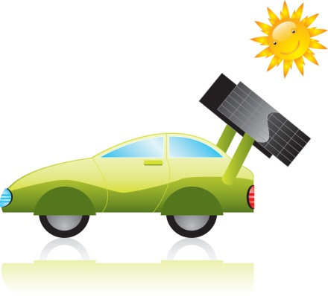**Renewable Energy**

**Select one of the following forms of renewable energy to research.**

|  |  |  |
| --- | --- | --- |
| Wind | Solar | Geothermal |
| Hydroelectric | Biomass | Biofuels |

**C:\Users\dmz237\AppData\Local\Microsoft\Windows\Temporary Internet Files\Content.IE5\US4D7F5J\MC900437705[1].wmfLinks:**

[**http://en.wikipedia.org/wiki/Renewable_energy**](http://en.wikipedia.org/wiki/Renewable_energy)

[**http://www.solarpowernotes.com/**](http://www.solarpowernotes.com/)

[**http://www.eia.gov/kids/**](http://www.eia.gov/kids/)

[**http://www.alliantenergykids.com/EnergyandTheEnvironment/RenewableEnergy/index.htm**](http://www.alliantenergykids.com/EnergyandTheEnvironment/RenewableEnergy/index.htm)

[**http://www.kids.esdb.bg/newenergy.html**](http://www.kids.esdb.bg/newenergy.html)

**Part 1: Research your form of renewable energy and answer the following questions on a separate sheet of paper:**

1. Where does your energy come from?
2. How much of this form of energy does the USA use?

(if you can find it: sometimes referred to as energy consumption and often given in percents)

1. What states are using this form of energy the most?
2. How much of this form of energy does the world use?
3. What countries are using this form of energy the most?
4. How is the energy collected and transformed into a usable form of energy?
5. Can this energy be used in homes and businesses? (explain how)
6. Can this energy be used in transportation? (explain how)
7. What are the advantages to using this form of energy?

(Is it clean? Green? Easily available? Inexpensive? Non-polluting?)

1. What are the disadvantages to using this form of energy?

(Drawbacks? Negative impacts on earth? Cost? Easily available?)

1. What is the history of this form of energy?

(Who invented it? Where? How? Improvements?)

1. Any other important/interesting facts?

**Part 2: Create a powerpoint or flip book that includes all of this information.**

**Part 3: Be prepared to present!**